LfcBpr User Guide

Version Number: 0.02
Date of Issue: 2021/4/29

Sea Zhou
dahai.zhou@lcfuturecenter.com

Cissie Gu
feng.gu@lcfuturecenter.com

The spec “Owner” is responsible for identification, maintenance, and publication of the controlled document.

Revision History
Date of Issue | Version | Owner | Revision Comments
2020/07/28 | 0.01 | Sea Zhou  Cissie Gu | - Draft version
2020/08/02 | 0.02 | Sea Zhou | - Add 2.5 Common
2021/04/12 | 0.03 | Cissie Gu | - Add that continue from the break.
2021/04/29 | 2.00 | Cissie Gu | - Remove ReadMe.txt, add LfcRelaseNote.txt to modify

Table of contents
1 Introduction 4
2 Preparatory 4
2.1 Insyde 4
2.2 Phoenix 4
2.3 ProjectConfig.ini 5
2.4 ReleaseNote.txt 5
2.5 Common 5
3 Run 6
3.1 Command Line: 6
3.2 GUI 7
4 Additional Information 8

Introduction
The LfcBpr is a tool to automatically build, sign and pack BIOS release package, it used on LNB projects, support Insyde and Phoenix codebase. This is the user guide to LfcBpr tool. LfcBpr stands for LCFC Feature Code Build Pack Release.

Preparatory

Insyde
- Get Insyde codebase with L05, L05 is a MUST.
- Make Insyde build pass, for example: nmake uefi64
- Merge Intel ME by yourself, this normally in ProjectPostBuild.bat, here is an example:
@echo ------------Pack ME------------
@if not defined PLFM_NAME set PLFM_NAME=TigerLake
@if not defined ME_VERSION set ME_VERSION=15.0.0.1224
@if not defined ME_BIN_NAME set ME_BIN_NAME=CSME_B0_Consumer_15.0.0.1224_prod
@if not defined PMC_BIN_NAME set PMC_BIN_NAME=PMC_B0_150.01.20.1009_prod
@if not defined TCSS_IOM set TCSS_IOM=IOM_B0_11.0008.0.0_prod
@if not defined TCSS_MGPHY set TCSS_MGPHY=PHY_B0_2.2022_prod
@if not defined TCSS_TBT set TCSS_TBT=TBT_B0_Rev27_preprod
cd ME\%ME_VERSION%
@fit.exe -b -f %WORKSPACE%\%PROJECT_REL_PATH%\%PROJECT_PKG%\ME\%ME_VERSION%\S540.xml -me %WORKSPACE%\%PROJECT_REL_PATH%\%PROJECT_PKG%\ME\%ME_VERSION%\CSME\Silicon\LP\%ME_BIN_NAME%.bin -bios %WORKSPACE%\%PROJECT_REL_PATH%\%PROJECT_PKG%\BIOS\%PLFM_NAME%.fd -pmcp %WORKSPACE%\%PROJECT_REL_PATH%\%PROJECT_PKG%\ME\%ME_VERSION%\PMC\%PMC_BIN_NAME%.bin -iom %WORKSPACE%\%PROJECT_REL_PATH%\%PROJECT_PKG%\ME\%ME_VERSION%\TCSS\IOM\%TCSS_IOM%.bin -nphy %WORKSPACE%\%PROJECT_REL_PATH%\%PROJECT_PKG%\ME\%ME_VERSION%\TCSS\MGPHY\%TCSS_MGPHY%.bin -tbt %WORKSPACE%\%PROJECT_REL_PATH%\%PROJECT_PKG%\ME\%ME_VERSION%\TCSS\TBTYFL\%TCSS_TBT%.BIN -o %WORKSPACE%\%PROJECT_REL_PATH%\%PROJECT_PKG%\bios_smt.bin
- Ensure the final BIOS output file name is bios_smt.bin, file location MUST be in the project folder, for example: Board\Oem\L05TigerLakeMultiBoardPkg\ bios_smt.bin. The bios_smt.bin is 16M or 32M raw BIOS binary file for SF100.
- Ensure the final crisis output file name is crisis.bin, file location MUST be in the project folder, for example: Board\Oem\L05TigerLakeMultiBoardPkg\crisis.bin. Here is an example:
@copy %WORKSPACE%\%PROJECT_REL_PATH%\%PROJECT_PKG%\BIOS\%PLFM_NAME%.fd %WORKSPACE%\%PROJECT_REL_PATH%\%PROJECT_PKG%\crisis.bin
- Add the project_XX.uni file for your BIOS build ID, normally copy it from project.uni. For example, your build ID is F5, then copy project.uni to project_F5.uni

Phoenix
- Get Phoenix codebase with OIL, OIL is a MUST
- Make Phoenix build pass, for example: PhMake.bat
- Ensure the final BIOS output file name is bios_smt.bin, file location MUST be in the project folder, for example: Phoenix\Projects\Celadon\000\bios_smt.bin. The bios_smt.bin is 16M or 32M raw BIOS binary file for SF100. Here is an example:
copy "$(BUILD_BIN_DIR)\$(PLATFORM_NAME)X64.bin" "$(BIOS_PATH)\bios_smt.bin"
- Ensure the final BIOS capsule file output file name is bios_cap.cap, file location MUST be in the project folder, for example: Phoenix\Projects\Celadon\000\bios_cap.cap. The bios_cap.cap is 17.x M or 33.x M BIOS capsule file made by UCWW.exe, could be used for Secure Flash and Secure Crisis, this normally in project.mak, here is an example:
@cd "$(BUILD_DIR)\FV\SecureFlash"
UCWW.exe \
-buildcap rsa2048 4 9166175-35F4-4A03-B45B-EF6FC908468A \
-bios "$(BUILD_BIN_DIR)\$(PLATFORM_NAME)X64.bin" \
-ufa "$(WORKSPACE)\$(SCT_MODULE_SYSTEM)\PhSystemBinPkg\FlashUpdateDriver\X64\SystemFlashUpdateDriverDxe.efi" \
-out bios_cap.cap
- Add the BIOS_Version_XX.def file for your BIOS build ID and be included by project_XX.def. The BIOS_Version_XX.def must contain the BIOS version string, for example:
Config BIOS_VERSION, "\"F0CN44WW\"" // set the revision of BIOS.

ProjectConfig.ini
Copy the Tool\ProjectConfig.ini into project folder and config it CAREFULLY

ReleaseNote.txt
Formal release package contain ReadMe.txt and Web_Release\Readme.docx, tool will not auto generate them, it must be human's work, so you must copy the Tool\TemplateLnb\LfcReleaseNote_XX.txt in your project folder,and modify what in the red rectangle, the format is showed as below:
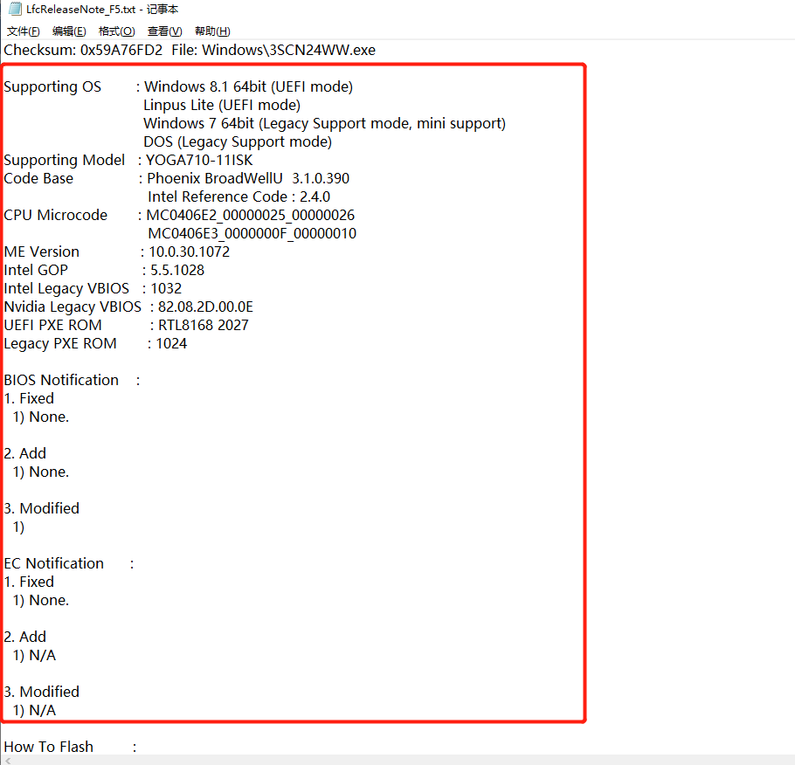
Tool will read the WHOLE FILE and put it into ReleaseNote.txt and extract to ReadMe .txt and Web_Release\Readme.docx.

Common
- Must install Mocca key for Mocca sign (local sign)
- Outlook must be installed and opened for LENOVO sign

Run
This tool no need to install, copy it to anywhere on your disk then run.
It has FIVE parameters to input:
PARAMETERS | MUST? | DESCRIPTION
Build ID | Mandatory | XX is normal build  XXC is build clean  XX1, XX2, XX3 please see the help message
BIOS Version | Optional | If not input, will use the version in BIOS code, it input, will use it to override BIOS code  10: major version 10, for example: A7CN10WW  10TTTTTT: major version 10 + test version TTTTTT, for example: A7CN10WWTTTTTT
Sign Type | Optional | If not input, default sign type is Mocca sign (local sign)  If input, sign type could be Mocca sign (local sign) or LENOVO sign (server sign)
Release Type | Optional | If not input, default release type is test release  If input, release type could be test release or formal release
Project Folder | Optional | The path to project folder  If not input, will use the tool folder as project folder

Command Line:
b.bat /? will show help message as below:
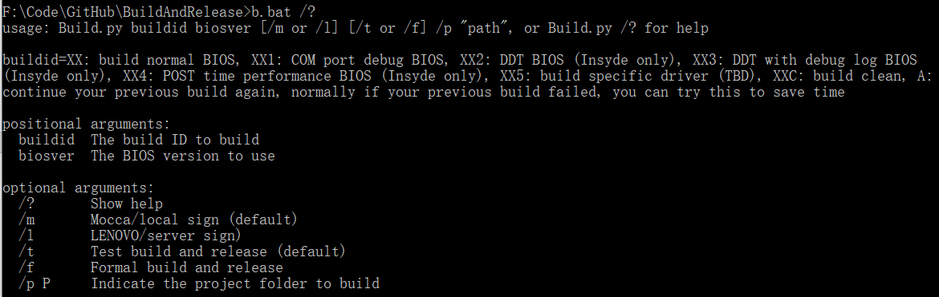

PARAMETERS | MUST? | USAGE
Build ID | Mandatory | b.bat XX /p "F:\Project\TGL\Tag0014\Board\Oem\L05TigerLakeMultiBoardPkg"
BIOS Version | Optional | b.bat XX VV /p "F:\Project\TGL\Tag0014\Board\Oem\L05TigerLakeMultiBoardPkg"
Sign Type | Optional | b.bat XX /m or /l /p "F:\Project\TGL\Tag0014\Board\Oem\L05TigerLakeMultiBoardPkg"
Release Type | Optional | b.bat XX /t or /f /p "F:\Project\TGL\Tag0014\Board\Oem\L05TigerLakeMultiBoardPkg"
Project Folder | Optional | b.bat XX /p "F:\Project\TGL\Tag0014\Board\Oem\L05TigerLakeMultiBoardPkg"
Because the tool can support any source code in your hard disk, so you must input the /p with source code path. If you only have one source code to build, you can choose one option below to remove the usage of /p:
- Copy the LfcBpr folder to your project folder
For example, copy the whole folder to project folder Board\Oem\L05TigerLakeMultiBoardPkg (Insyde) or Phoenix\Projects\Celadon\000 (Phoenix)
- Modify the b.bat
BEFORE:
@Tool\Python38\python.exe LfcBpr.py %1 %2 %3 %4 %5 %6
AFTER:
@Tool\Python38\python.exe LfcBpr.py /p "F:\Project\TGL\Tag0014\Board\Oem\L05TigerLakeMultiBoardPkg" %1 %2 %3 %4 %5 %6

GUI
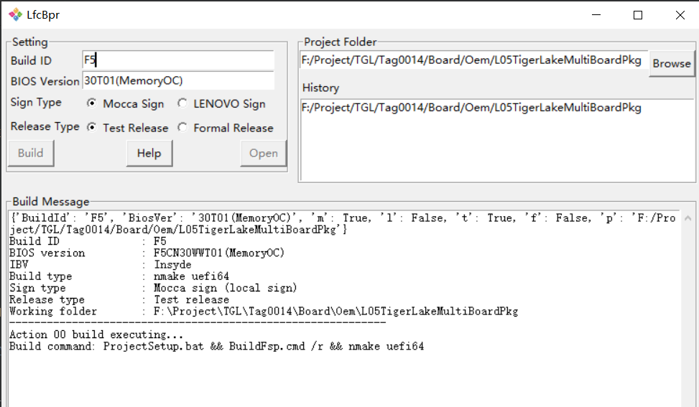

PARAMETERS | MUST? | USAGE
Build ID | Mandatory | See picture  Note: If you need to continue to build from break, you can use BuildID: A to build it again.
BIOS Version | Optional | See picture
Sign Type | Optional | See picture
Release Type | Optional | See picture
Project Folder | Optional | See picture

Continuous build from break note:
Most of all, we face that the server cannot reply or give the signed BIOS slowly. At this time, we often sign the input.7z manually, then we can use the BUILD ID A to go on.

- Put the signed package into the LfcBprOutput\xxx\06_wait_for_sign_back\. XXXX must be the newest document under the LfcBprOutput

2. Copy and override the green marked part to the LfcBprOutput\xxx\data.json and modify the address as your own project.

"06_wait_for_sign_back_output": {
"file": "LfcBprOutput\\2020-12-25-17-52-44-GZCN07WW\\06_wait_for_sign_back\\Signed.7z"
},
"06_wait_for_sign_back_result": 0,
"07_tool_7z_uncompress1_output": {
"file": "LfcBprOutput\\2020-12-25-17-52-44-GZCN07WW\\07_tool_7z_uncompress1\\Unzipped1"
}
- Open LfcBpr, type A in the BUILD ID input box then build.
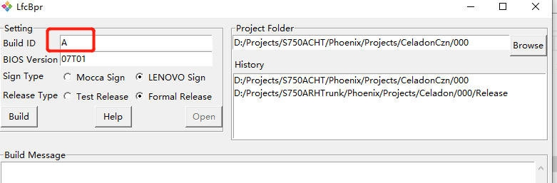

Additional Information
- Tool will copy all aaaaaa_XX.bbb in the project folder to aaaaaa.bbb, so you can create Project_XX.env, ProjectPostBuild_XX.bat, Project_XX.var, project_XX.def if necessary
- Tool will always build FSP for Intel platform

